1. The class created is Laptop. Instances are myLaptop and abuLaptop.

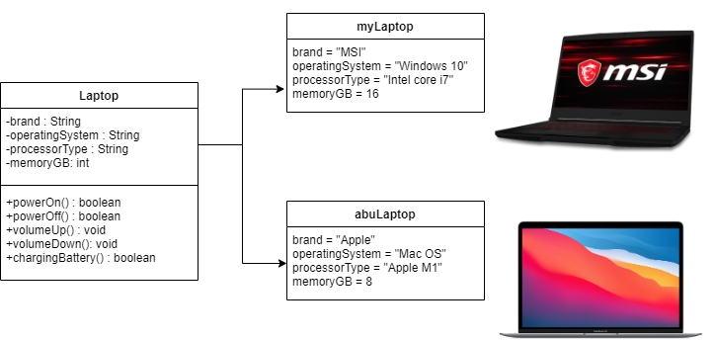

1. The class created is Rectangle. Instances are rectangle1 and rectangle2.

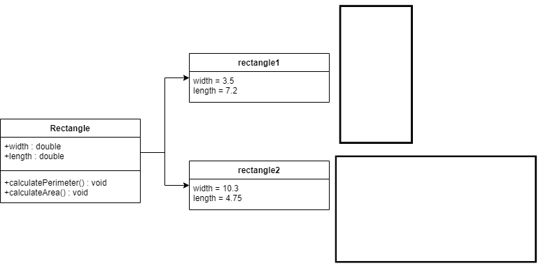

1. The class created is Student. Instances are student1 and student2.

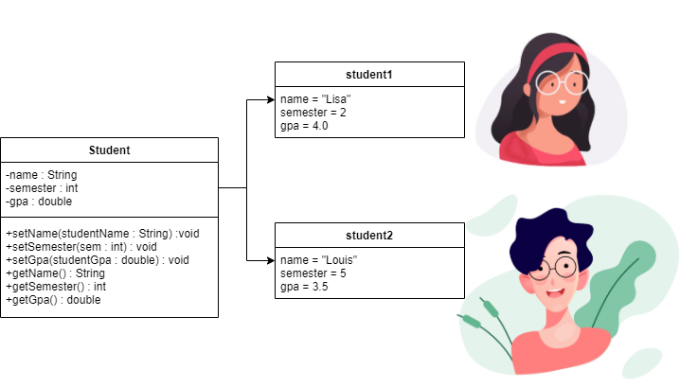

1. The class created is Backpack. Instances are myBackpack and abuBackpack.

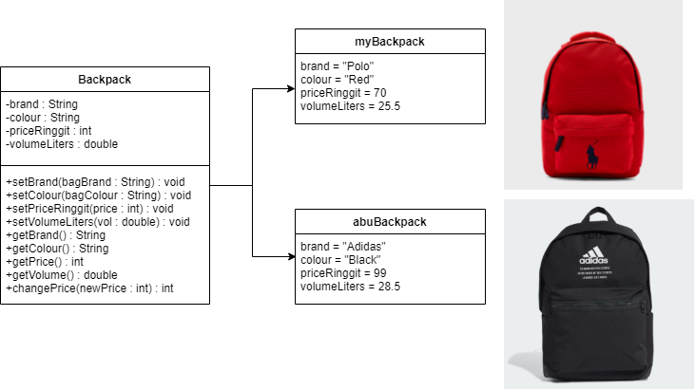

1. The class created is Dog. Instances are myDog and samanthaDog.

